
Mechanics of Material

Merged MEEN325
Lab Report
Water Tunnel
The PI honor pledge:
“I pledge that I have neither given nor received any unauthorized assistance on this laboratory report assignment”
Submitted To: Shrinivas Bojanampati
Report submission date: 28/11/2019
Submitted by: Group B
Student Name: | Student ID | Signature
Sultan Alzarooni | 100052093 | A
Haytham Imad | 100050152 | B
Abdulaziz Albluoshi | 100050151 | C
Ahmed Nasser | 100052099 | D

Outline

Objectives -----------------------------------------------------------------
Introduction ---------------------------------------------------------------
Experimental Set-up ------------------------------------------------------
Procedures -----------------------------------------------------------------
Results ----------------------------------------------------------------------
Discussion ------------------------------------------------------------------
Conclusion ------------------------------------------------------------------
References ------------------------------------------------------------------

Objective
- Understand the principles of laser Doppler Velocimetry (LDV)
- Measure the velocity of the flow downstream and upstream of circular cylinder.
- Obtain velocity profile of downstream and upstream of a circular cylinder.
- Determine the Reynolds number and Strouhal numbers.
- Estimate the drag on the cylinder.

Introduction
(Theoretical background from lab manual all equation must be stated here)

Experimental Set-up
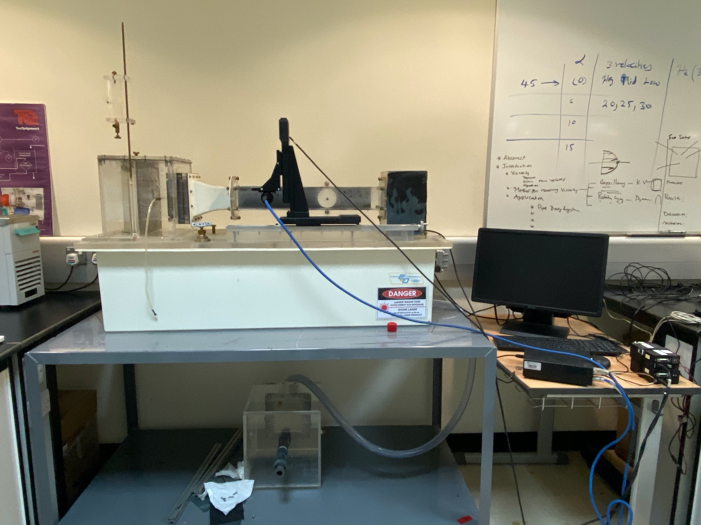
Dye Injector
Dye Valve
Head Tower
Control Valve
Water Reservoir
Contraction
Top Vent
Three-Axis Traverse
Weir Exit Plenum
Desk
Wall Plug w/ Airfoil
Interchangeable Test Section

Procedures

- Install the wall plug with the attached cylinder into the Interchangeable Model Test Section.
- Install the Interchangeable Model Test Section and Weir Exit Plenum into the Fluid Laboratory System. Ensure the wall plug is mounted in the wall opposite the MiniLDV sensor.
- Secure the flow and drain the Test Section.
- Remove the Wall Plug and measure the cylinder diameter with a calipers. Replace the Wall Plug.
- Start the submersible pump and establish desired flow by varying the valve.
- Setup the MiniLDV. Refer to Appendix B for operation of MiniLDV.
- Turn on the LDV system. Once the system is turned on and the BP software initialized, two red beams should be visible emerging from the probe and passing through the water tunnel test section.
- Run the NI scope and set proper Time period and Voltage. Doppler bursts should start appearing on the oscilloscope. Calculate the frequency from the plot on the scope and enter the frequency value into the software under Acquisition Expected Frequency
- Calculate the velocity of the flow using the frequency.

U = f * 3.52
Compare this value to the value of velocity generated using the software.

- Obtain the velocity profile by positioning the probe using the traverse at locations indicated in the Table 1 and establish the average freestream velocity by placing the probe.
- Acquire the data using Single Point Acquisition mode. Press Acquire button to record the data. Check the ‘Save’ checkbox to save the file. Record the values Ubar and U’ into the Table 1.
- Using the profile acquisition measure the velocity profile above and below the cylinder and record your data in Table 2.

Results

Discussion

Conclusion

References

